
SOUTH EAST EDUCATION DIVISION EXAMINATIONS

2026 MALAWI SCHOOL CERTIFICATE OF EDUCATION MOCK EXAMINATION

BIOLOGY
Subject Number: M022/I
Tuesday, 17 March Time Allowed: 2 hours
8:00 - 10:00 am
PAPER I
(100 marks)
Theory
Instructions:

- This paper contains 12 printed pages. Please check.
Question Number | Tick if answered | Do not write in these columns
1
2
3
4
5
6
7
8
9
10
11
12
13
- Fill in your Examination number at the top of each page.
- This paper has two sections, A and B. In Section A there are fourteen short questions while in section B there are three restricted essay questions.
- Answer all the seventeen questions in the spaces provided.
- Use of electronic calculators is allowed
- The maximum number of marks for each answer is indicated against each question.
- In the table provided on this page, tick against the number of the question you have answered.

©2026 SEED MOCK Turn over

Section A (70marks)
Answer all questions in this section in the spaces provided

1. a. State any two disorders in a hemophilic person
_____________________________________________________________________________________________________________________________________________________ 2 marks
- Explain how the gene of hemophilia arise in population
__________________________________________________________________________________________________________________________________________________________________________________________________________________________________ 2 marks
c. Explain how steady flow of carbon dioxide between air and the mesophyll is maintained in a
leaf during the night
__________________________________________________________________________________________________________________________________________________________________________________________________________________________________ 3 marks

2. a. Name any one hormone involved in osmoregulation
_______________________________________________________________________ 1 mark
b. Explain why blood of a patient and dialysis fluid move in opposite directions in a
dialysis machine
_____________________________________________________________________________________________________________________________________________________2 marks

3. a. State any two functions of large intestines in the alimentary canal
_____________________________________________________________________________________________________________________________________________________ 2 marks
b. Explain how an injury to the medulla might cause death
____________________________________________________________________________________________________________________________________________________ 2 marks

4. Fig 1 shows a plant tissue obtained from a stem. Use it to answer the questions that follow
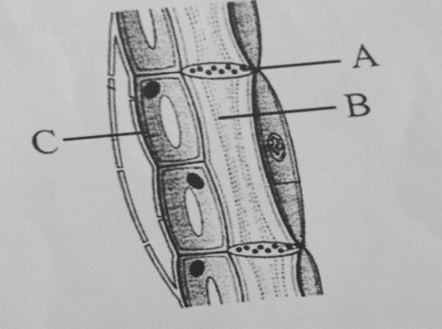
Figure 1
a. Name the part labelled A and B
A _____________________________ B ______________________ 2 marks
b. Explain function of part labelled C
________________________________________________________________________________________________________________________________________ 2 marks
c. Describe one adaptation of the structure to its function
________________________________________________________________________________________________________________________________________________ 2 marks

5. a. Mention any two causes of maternal death
____________________________________________________________________________________________________________________________________________________ 2 marks
b. Explain how HPV vaccine can protect women from cervical cancer
____________________________________________________________________________________________________________________________________________________ 2 marks

6. a. What is speciation?
_____________________________________________________________________________________________________________________________________________________ 1 mark
Continued/…
b. Explain two ways in which new species of organisms can arise in an environment
_________________________________________________________________________________________________________________________________________________________________________________________________________________________________________________________________________________________________________________ 4 marks

7. Fig 2 is a diagram showing a human cell undergoing mitotic cell division. Use it to answer the
questions that follow.
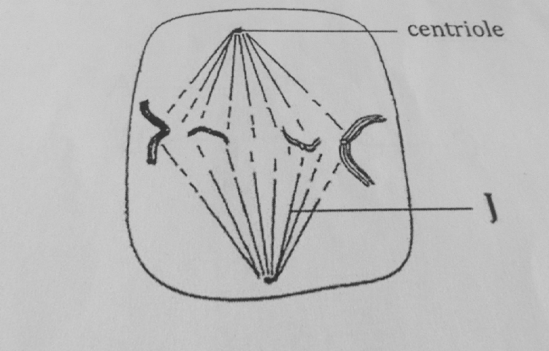
Figure 2
- Identify the stage
_________________________________________________________________ 1mark
- Give a reason for your answer to 6 (a) above
__________________________________________________________________ 1 mark
c. What is the function of part labeled J
___________________________________________________________________ 1 mark
d. State two functions of DNA in the body
___________________________________________________________________________________________________________________________________________________________________________________________________________________________________ 2 marks

Continued/…
8. a. State any one use of the median fins in fish
_____________________________________________________________________________________________________________________________________________________ 1 mark
b. Explain how swim bladder controls change in its depth in water
__________________________________________________________________________________________________________________________________________________________________________________________________________________________________ 2 marks
c. Describe how fish create forward motion
___________________________________________________________________________________________________________________________________________________________________________________________________________________________________ 2 marks

9. a. List any two limitations of using quadrat method when sampling organisms
_____________________________________________________________________________________________________________________________________________________ 2 marks
b. Describe any one way in which atmospheric nitrogen is made available to plants
__________________________________________________________________________________________________________________________________________________________________________________________________________________________________ 2 marks
c. Explain how the heart muscle helps in creating systolic pressure
_____________________________________________________________________________________________________________________________________________________ 2 marks

10. a. Name the causative agent of typhoid fever
_______________________________________________________________________ 1 mark
b. State any two ways of preventing the spread of typhoid
___________________________________________________________________________________________________________________________________________________________________________________________________________________________________ 2 marks
Continued/…
11. a. What is meant by diffusion gradient?
_____________________________________________________________________________________________________________________________________________________ 1 mark
b. Explain how concentration gradient affect rate of diffusion of a substance
__________________________________________________________________________________________________________________________________________________________________________________________________________________________________ 2 marks

12. Table 1 below shows blood groups of a certain family. Use it to answer the questions that
follow
Father | Mother | Daughter | Son
A | B | AB | O

a. What is the genotype of the father?
_____________________________________________________________________1mark
b. Which member of the family can donate to all the family members?
_____________________________________________________________________ 1 mark
c. Explain what would happen if the member mentioned in12. (b) above receives blood from any
member of the family
___________________________________________________________________________________________________________________________________________________________________________________________________________________________________ 2 marks

13. Figure 3 below shows a process happening on the body of a human being. Use it to answer the questions that follow.
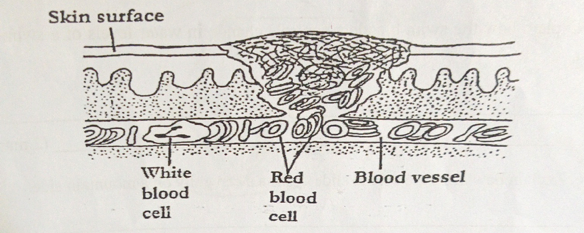
Figure 3
a. Name the process that is happening
_____________________________________________________________________ 1 mark
b. Explain any two importance of the process in human body
________________________________________________________________________________________________________________________________________________________________________________________________________________________________ ( 4 marks)
c. Discuss any two application of biotechnology
_________________________________________________________________________________________________________________________________________________________________________________________________________________________________________________________________________________________________________________ 2 marks

14. a . Give any one importance of synapses in the nervous system.
_____________________________________________________________________________________________________________________________________________________ 1 mark
b. State any two adaptation of a synapse in transmitting impulse from one neurone to another
___________________________________________________________________________________________________________________________________________________________________________________________________________________________________ 2 marks
Continued/…
c. How does myelin sheath affect the movement of impulse in a neurone?
___________________________________________________________________________________________________________________________________________________________________________________________________________________________________ 2 marks
c. State three importance of palliative care to people suffering from terminal illness like cancer
__________________________________________________________________________________________________________________________________________________________________________________________________________________________________________ 3 marks
SECTION B. (30 marks)
Answer all questions in an essay form
15. Explain any five impacts of human activities on freshwater ecosystem in Malawi
______________________________________________________________________________________________________________________________________________________________________________________________________________________________________________________________________________________________________________________________________________________________________________________________________________________________________________________________________________________________________________________________________________________________________________________________________________________________________________________________________________________________________________________________________________________________________________________________________________________________________________________________________________________________________________________________________________________________________________________________________________________________________________________________________________________________________________________________________________________________________________________________________________________________________________________________________________________________________________________________________________________________________________
Continued/…
________________________________________________________________________________________________________________________________________________________________________________________________________________________________________________________________________________________________________________ 10 marks

16. Explain any five evidence of evolution.
____________________________________________________________________________________________________________________________________________________________________________________________________________________________________________________________________________________________________________________________________________________________________________________________________________________________________________________________________________________________________________________________________________________________________________________________________________________________________________________________________________________________________________________________________________________________________________________________________________________________________________________________________________________________________________________________________________________________________________________________________________________________________________________________________________________________________________________________________________________________________________________________________________________________________________________________________________________________________________________________________________________________________________________________________________________________________________________________________________________________________________________________________________________________________________________________________________________________________________________________________________________________________________________________________________________________________________________ 10 marks
Continued/…
17. Explain any five adaptations of the placenta to its function
____________________________________________________________________________________________________________________________________________________________________________________________________________________________________________________________________________________________________________________________________________________________________________________________________________________________________________________________________________________________________________________________________________________________________________________________________________________________________________________________________________________________________________________________________________________________________________________________________________________________________________________________________________________________________________________________________________________________________________________________________________________________________________________________________________________________________________________________________________________________________________________________________________________________________________________________________________________________________________________________________________________________________________________________________________________________________________________________________________________________________________________________________________________________________________________________________________________________________________________________________________________________________________________________________________________________________________________________________________________________________________________________________________________________________________________________________________________________________________________________________________________________________________________________________________________________________________ 10 marks
END OF QUESTION PAPER
NB: This paper contains 10 printed pages.

